Apedog User Manual

# Installation

# Configuration

Open index.html and login as **MC** (case sensitive) and password **aiesec** (you can change it later).

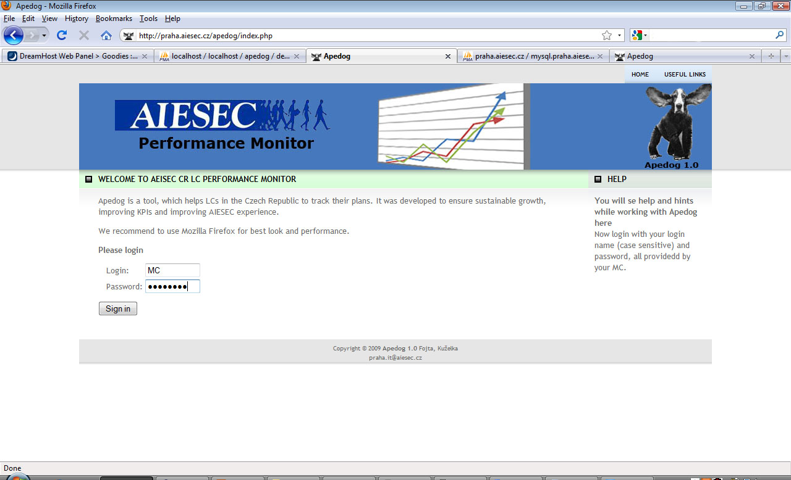

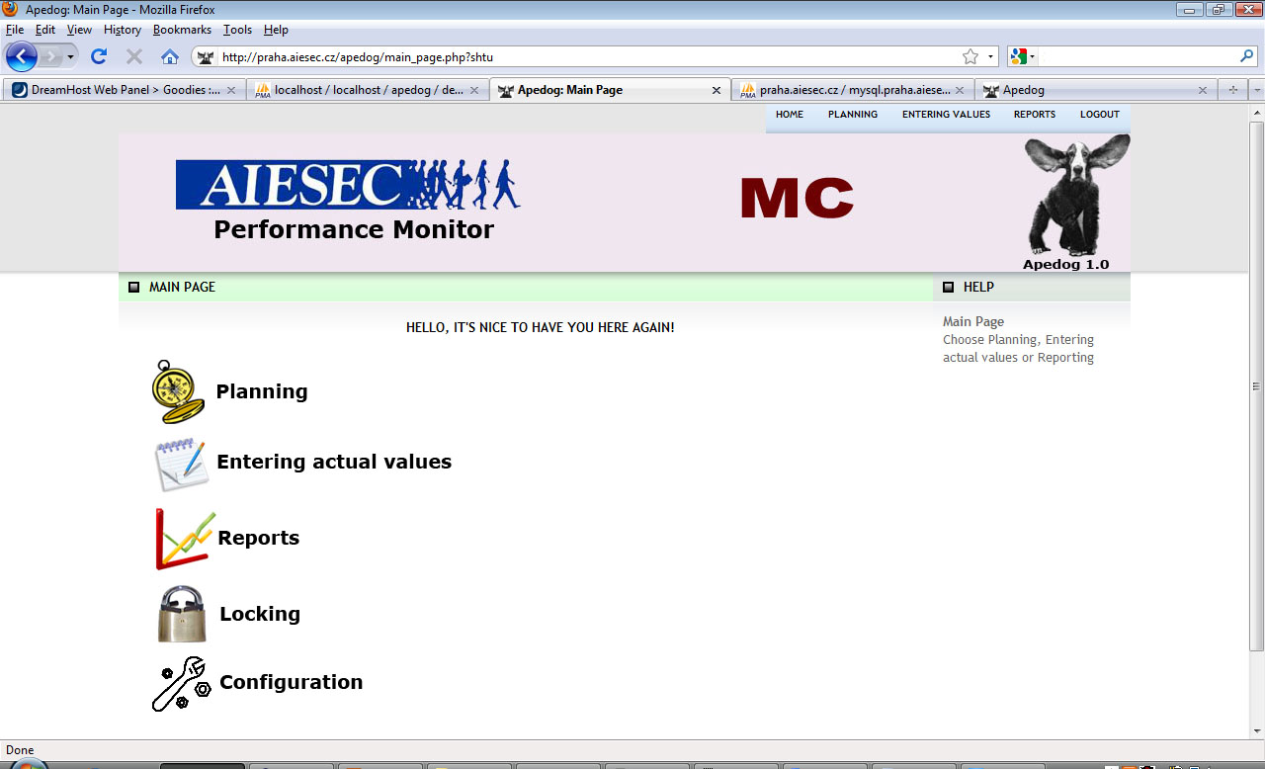

Now go to configuration to set everything what is needed

Firstly, we will set other LCs and its users.

Go to “LC” configuration.

As you can see, there already is MC, you need it and some its user in order to use configuration. Its users can also lock others’ LCs’ Planning and Entering actual values and can see more wide output (also from LCs)

We will make other LCs. So we want use **“new – create new item”.** If you want to have different pictures for LCs, put picture in images folder on server in form of img02_LCname.jpg in the same scale as img02.jpg is**.** And it is case sensitive for most browsers.

We make LC called Praha and we put picture images/img02_Praha.jpg on server. Description is voluntary. And save it by pressing “Save”.

You can edit or delete all items by pressing on them in a list under “new – create new item”. Created and updated columns shows date when specific item was created and updated and it is changed automatically when you press save so you don’t have to edit it manually.

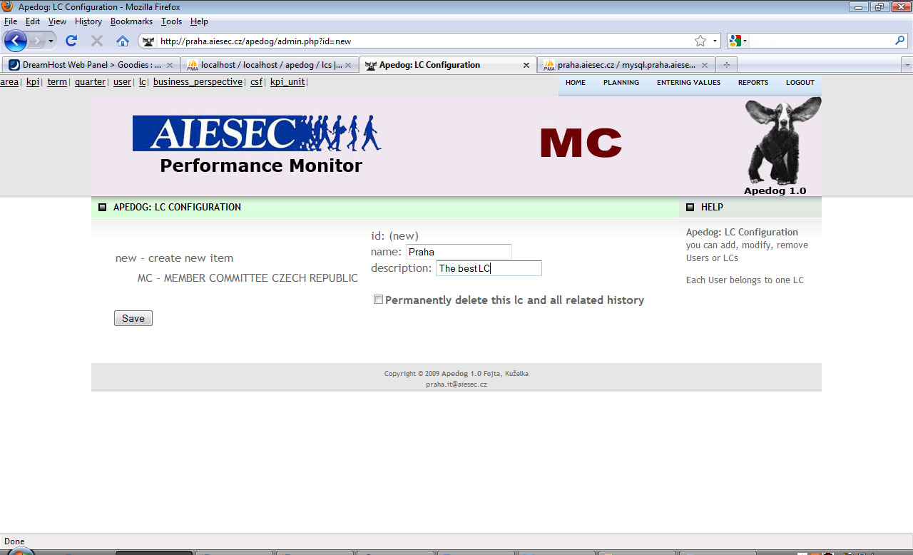

For adding User for this LC we either press on LC and use Add new User or we go to User configuration manually.

So we want to add User Kryštof Kuželka and as we won’t make other users for Praha, we can set his login as Praha. We choose his password and choose mail, where, if Praha LC forgets to enter actual values for some KPI even after 25 days after the end of quarter, mail with reminder will be sent. We also mustn’t forget to check if the right LC (Praha) is chosen.

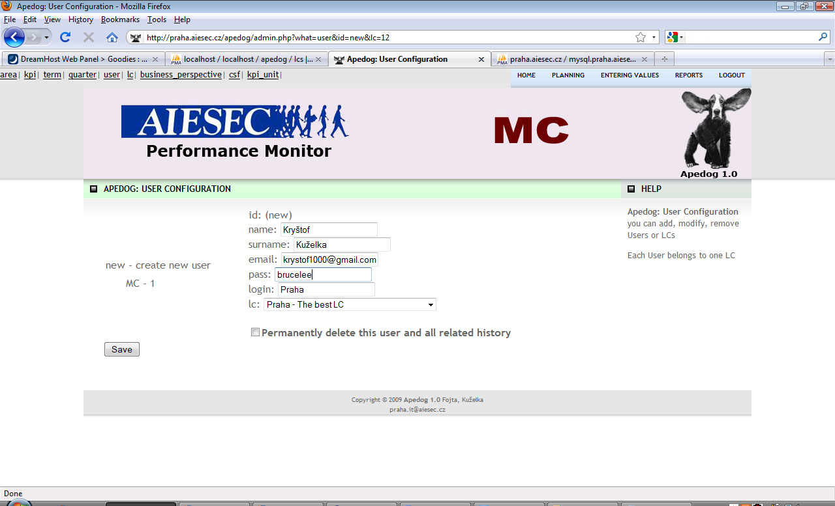

OK, now we will prepare everything needed for planning and entering values.

Firstly we go to term configuration and configure some terms. We set value of term as an order for all lists of terms (the best idea is to set number 1 for first term we are tracking, number 2 for second etc.)

Now we similarly define quarters for terms. We decided to use quarters as the best time period for us as month is so short time to enter values for 50 KPIs or so. Of course you can make 12 quarters in term and choose periods whatever you like but it will still be called quarters. Quarter_in_term has similar function as number_of_term in term. It also determines order of quarters and allows choosing which the quarter that was year ago is.

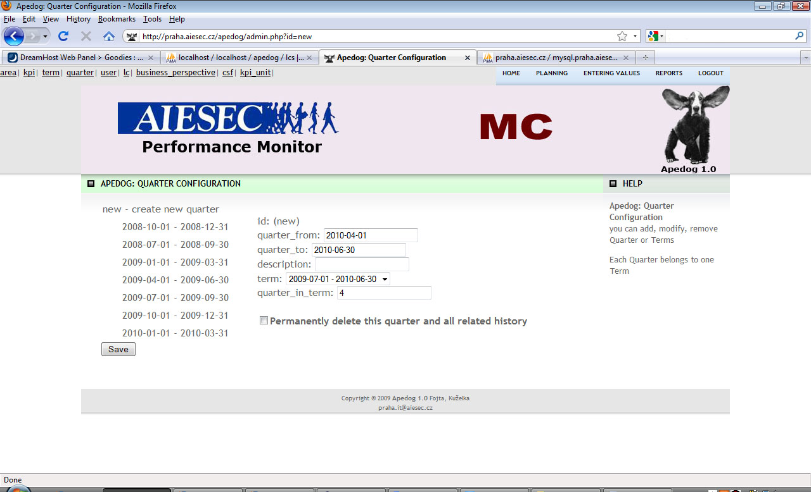

Next important thing for planning and entering values are **Functional areas.** Every KPI must be in area. We can make some areas in Area configuration.

When we are done with that, we prepare what is needed for setting KPIs – the key stone of system.

We would definitely like to make some list of units available for KPIs. To do that, go to the **kpi_unit.**

The name of kpi unit is what will be shown right next to every value of this KPI.

Spec means specification. The only thing that matters is if you type in boolean. That will cause, this KPI won’t have input field but dropdown menu with yes/no. If you choose boolean and type in name it next to yes/no, you don’t have to do it.

Description is just for your information, what is meant by this KPI.

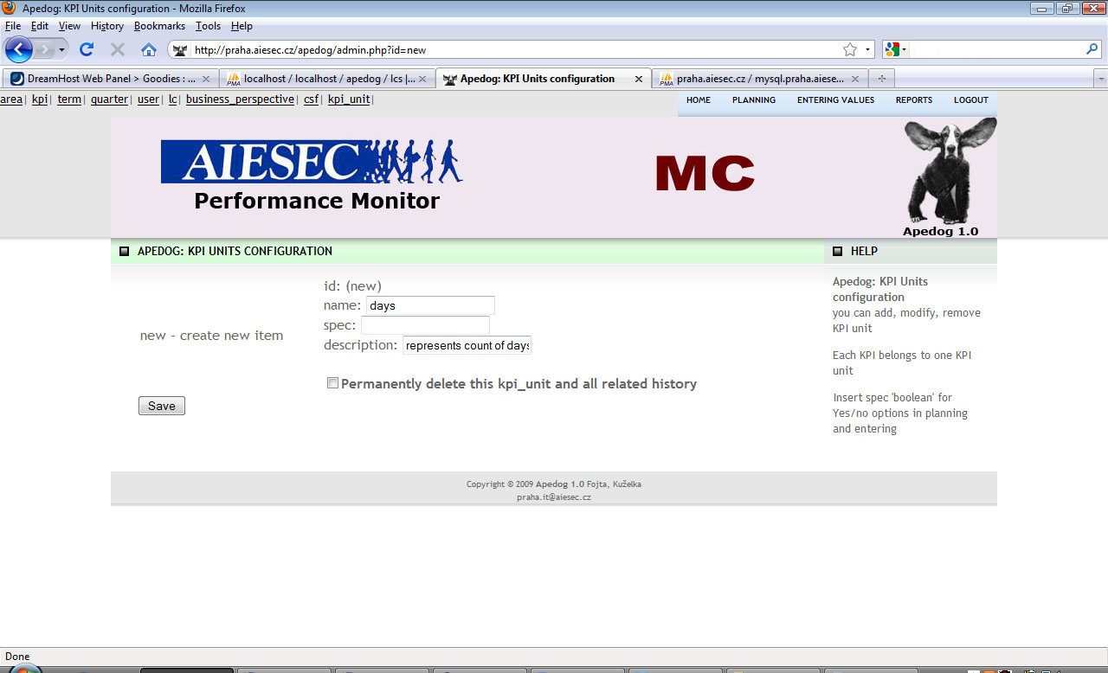

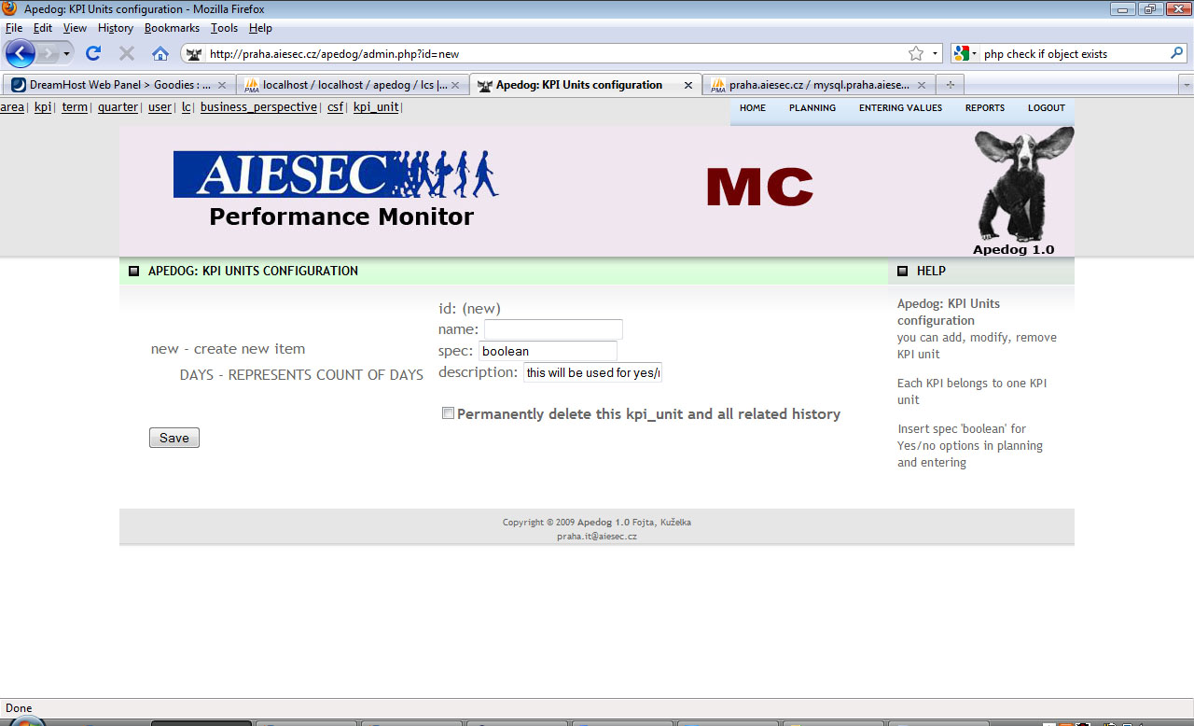

I will make several other units like ‘%’, ‘CZK’ (it is Czech currency), etc

Now we will set **Critical success factors and Business_perspectives** which are important in reports.

I will create some BPs in BP configuration. The order, how you create it, will take effect in order in Reports so think twice before you create it.

For each BP I will create some CSFs. If you delete BP, CSF remains but loses its parent. If CSF doesn’t have a parent, it isn’t shown in **Reports** in **BSC Results** but it is in next tab in results – **LC’s KPIs**. So two important thing when setting CSF: set some description in order to provide help (it shows up when user roll over CSF in Results) and choose either some BP or null in order to show this CSF in BSC Results tab or LC Kpis tab (this tab is used for KPIs that aren’t defined for all LCs, that means it shouldn’t be KPI from Balance score card=>when you create CSF and don’t put it into BP, this CSF usually represents some internal group for specific LCs KPIs, not real CSF – I will demonstrate it while setting KPIs).

BP->CSF->KPI creates tree structure and if you don’t have Balance score card you could call these ‘groups’ differently. Nevertheless, you can easily use it. Put your indicators(KPI) into some group(CSF) and these groups put into another parent group(BP).

We can move to the last thing left to configure but is most important.

**KPI:**

* Name: Name of KPI
* Description: Help when user roll over KPI (same as for CSF)
* Area: definitely choose one of function areas we made before
* CSF: if you want to have this KPI in BSC Result tab choose CSF
* Kpi_unit: if you want to have a unit next to value of KPI or if you want to have boolean choice choose one of KPI units we defined before
* Graphs: type of graph used for this KPI
* End_of_term: Imagine your LC made 3 of something for this KPI in first quarter, 5 in second, 2 in third and 4 in fourth. What should be value at the end of term? Is it sum? Is it the last value (4)?
* All_lcs: quite similar. Imagine first LC achieved 5Xs, second LC 3, third 7. What is the output for whole country? Is it sum? It probably is. But what if you have percentage? Average? What if it is yes or no? If at least one yes => yes? It is just some kind of logic.
* Lc: which LC should have this KPI? It is multi select (use ctrl, tab). Probably all LCs should have the same KPIs in Balance Score Card Results tab. That means that those KPIs must be in CSF and those CSFs should be in BPs. In the second tab in Results it is different. I will make some special KPI just for Prague, that other LCs won’t have. Then make some CSF for it or not, it is not important, it will be shown in second tab in Results anyway. Either in group or single. What is important is that I won’t put this CSF in BP, because then whole CSF with all KPIs in it would move into first tab. We made it this way, so LCs can have their own KPIs in groups as well.

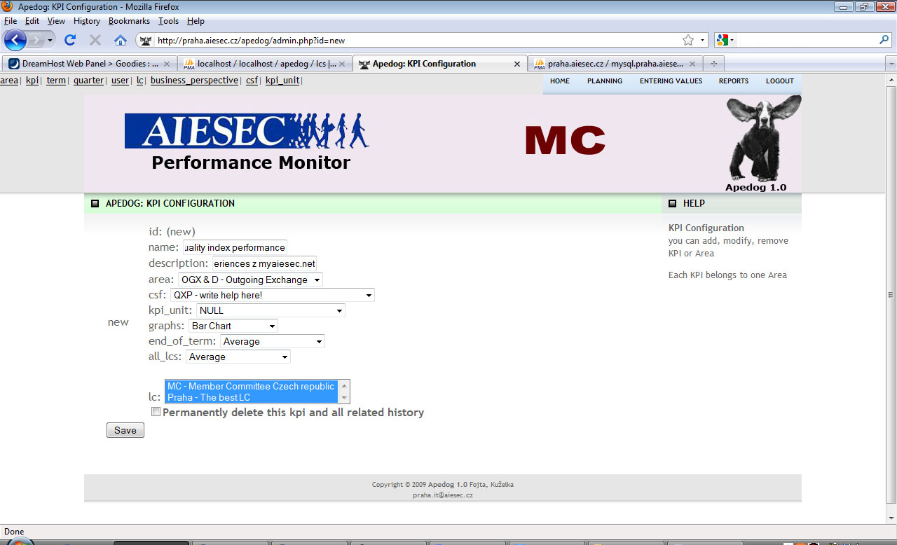

That is all for the configuration. Your country can start to use Apedog.